PEP Download and Import Instructions for Daily Activity

To complete the PEP Daily Activity Import, there are 2 main steps to be completed.

Part 1 is downloading the files.

Part 2 is importing it into Inn-Flow.

Part 1:

Within PEP, run the below reports and save these in excel:

Final Audit V2 (can be found in PEP under List of Reports, NOT Dynamic Reports)
Market Segment Summary (can be found in the Dynamic Reports)
Hotel Statistics (can be found in the Dynamic Reports)

Part 2:

- Within Inn-Flow, go to Daily Activity Entry.

- Select Import.

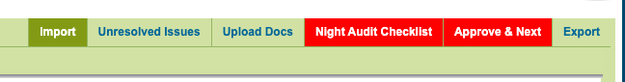

- Select the Upload/Import PMS button.

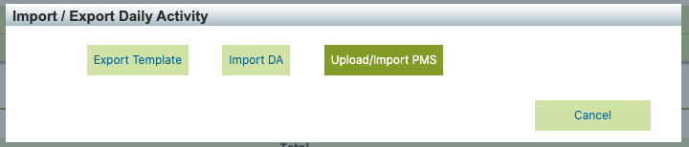

- Select Upload on the top right of the page.
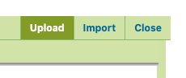

- Select Choose Files and select the three files saved from Part 1 above.

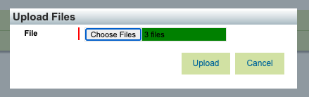

- Select Upload. You should get three green checks on the left side.

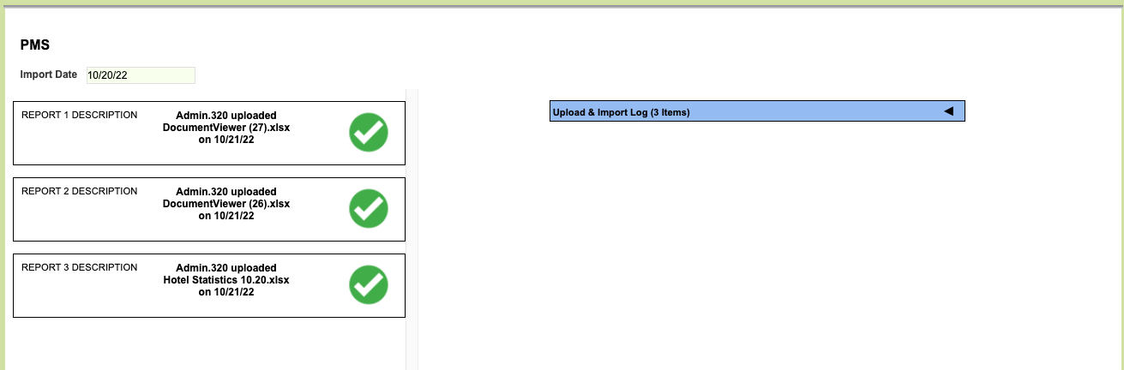

- You can expand the Upload Log on the right if there is an error. This will show if any reports do have an error.

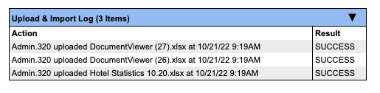

- Then select the Import button on the top right of the page to import the data:

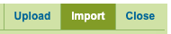

- This will remove any previously entered data and overwrite it per the reports. Select OK to continue.

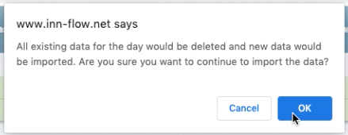

- You’ll receive a pop-up when your files have been imported successfully. Select OK.

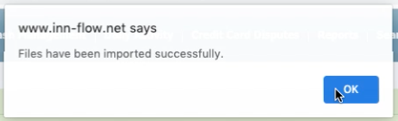

- Then select Close on the top right of the screen to proceed back to Daily Activity Entry.

- If you receive a pop-up like below, stating that there are auto-import errors, select OK.

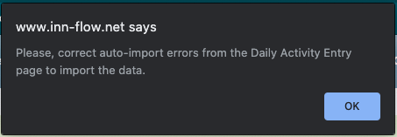

- Please create a Support Ticket by emailing Support@Inn-Flow.com, or by selecting the Help button on the bottom right of the page. We will take care of the error so that it imports correctly moving forward.

This occurs when a new code has been used that has not been created or mapped yet. Once we map the new code, it will import correctly moving forward.

- From there, select the Upload Docs button to import the PDF reports. This version of the reports is helpful for reference or any review that may be needed.

- Complete the Night Audit Checklist and the Manager Approval.

