PEP Download and Import Instructions for Daily Activity

To complete the PEP Daily Activity Import, there are 2 main steps to be completed.

Part 1 is downloading the file.

Part 2 is importing it into Inn-Flow.

Part 1:

Within PEP, run the below reports and save these in excel:

Final Audit V2
Market Segment Summary
Hotel Statistics

Part 2:

- Within Inn-Flow, go to Daily Activity Entry.

- Select Import.

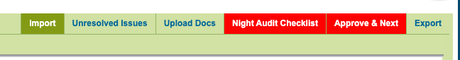

- Select the Upload/Import PMS button.

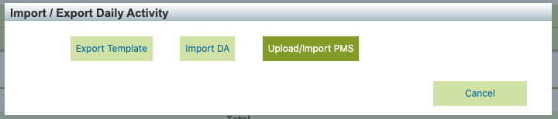

- Select Upload on the top right of the page.
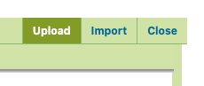

- Select Choose Files and select the three files saved from Part 1 above.

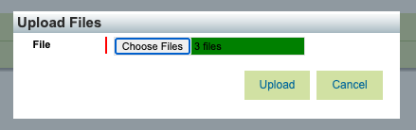

- Select Upload. You should get three green checks on the left side.

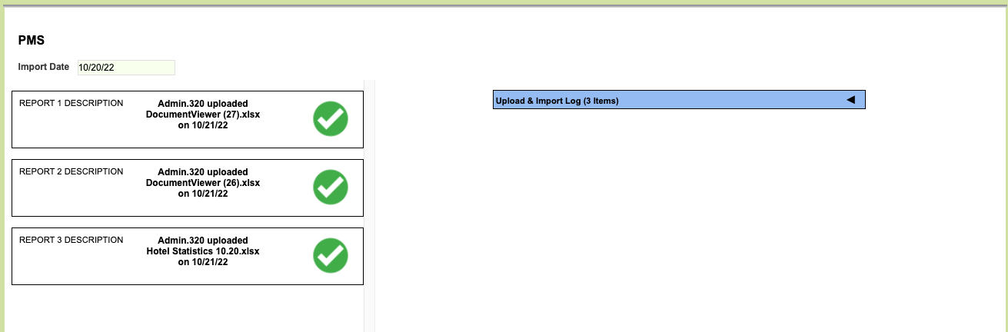

- You can expand the Upload Log on the right if there is an error. This will show if any reports do have an error.

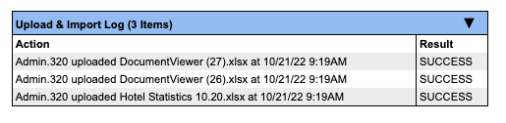

- Then select the Import button on the top right of the page to import the data:

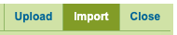

- This will remove any previously entered data and overwrite it per the reports. Select OK to continue.

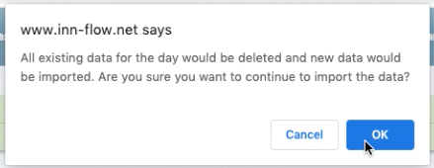

- You’ll receive a pop-up when your files have been imported successfully. Select OK.

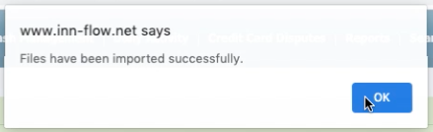

- Then select Close on the top right of the screen to proceed back to Daily Activity Entry.

- If you receive a pop-up like below, stating that there are auto-import errors, select OK.

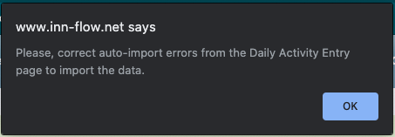

- Please create a Support Ticket by emailing Support@Inn-Flow.com, or by selecting the Help button on the bottom right of the page. We will take care of the error so that it imports correctly moving forward.

This occurs when a new code has been used that has not been created or mapped yet. Once we map the new code, it will import correctly moving forward.

- From there, select the Upload Docs button to import the PDF reports. This version of the reports is helpful for reference or any review that may be needed.

- Complete the Night Audit Checklist and the Manager Approval.

